**PROGRAMMING 3C**

**PROG7313**

**POE PART 1: research document**

**Group Members:**

Khatija Moosa Amod – ST10258766

Atiyyah Moola – ST10053786

Yashna Komla – ST10202387

Aisha Bilal Jakhura – ST10268917

**Part 1 – Research:**

**1. Introduction**

In today's fast-paced world, effective budgeting is essential for financial stability and achieving long-term financial goals. With the rise of mobile technology, budgeting apps have become powerful tools that help users track expenses, manage income, and plan for the future. This research aims to analyze three existing budgeting apps—**Money Tracker, YNAB (You Need a Budget), and Timely Bills**—to evaluate their features, strengths, and weaknesses. By understanding what these apps offer, we can identify key functionalities that should be included in our budgeting application.

This research is structured as follows:

* **Research Section:** Each of the three selected apps is examined individually. For each app, we provide:
  + An **overview** with screenshots and descriptions.
  + A discussion of its **strengths and weaknesses**, focusing on usability, features, and user experience.
  + An evaluation of its **innovative features** and an explanation of why these features stand out.
* **Infographic Comparison:** A visual representation comparing the three apps, highlighting their similarities and differences.
* **Feature Selection for Our App:** Based on our findings, we identify the best features from all three apps that should be integrated into our budgeting app. The selection is justified based on their usefulness and effectiveness.
* **Conclusion:** A summary of key insights from the research and how they inform the design of a new budgeting app.
* **Referencing:** A list of sources used in the research to ensure credibility and proper attribution.

**2. Research**

**App 1: Money Tracker**

1. **Overview including screenshots with description**

Money Tracker is an expense tracker and budgeting app that helps users track spending, save money, plan for the future and consolidate all the users' finances in one place (Money Tracker, 2022).

The app allows users to record personal and business transactions, generate spending reports, review daily, weekly and monthly financial data, and use the spending tracker and budget planner to manage assets (Money Tracker, 2022).

The main interface consists of the following key tabs:

Records page: This is the first tab users see when they open the app. It provides a detailed explanation of their financial activities for the specific month that they choose across multiple different accounts. Users can select a record to view a more detailed view of that activity. At the top of the tab is a section that shows users exactly how much money they earned, spent, and saved for that specific month. (Money Tracker, 2022)

Adding Finance tab: This tab makes use of buttons located at the top of the page to select whether they are adding an expense, income, or transferring into an account. The income and expense tab allows users to select an icon that represents various categories where they can allocate money, add a note, and add a picture, this data is saved and added to the records page. The transfer tab allows users to add multiple accounts that they will use or that they are sending money to (Money Tracker, 2022).

Charts Page:

This page utilizes a dropdown menu where users can select if they want to view their expenses or income analytics in a simple infographic (Money Tracker, 2022).

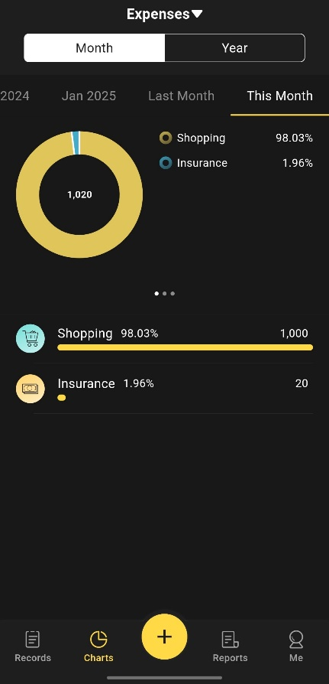

Money Manager: This page shows users their budget and expenses as a graph so that they can see the amount of their expenses against their budget quickly and efficiently. This page also allows users to create budgets and notify them when they exceed their budget (Money Tracker, 2022).

Scheduled payments page: This page allows users to organize bills and keep track of due dates. Users can choose how often they want to pay a specific person; they can customize the amount, and edit the start date and currency (Money Tracker, 2022).

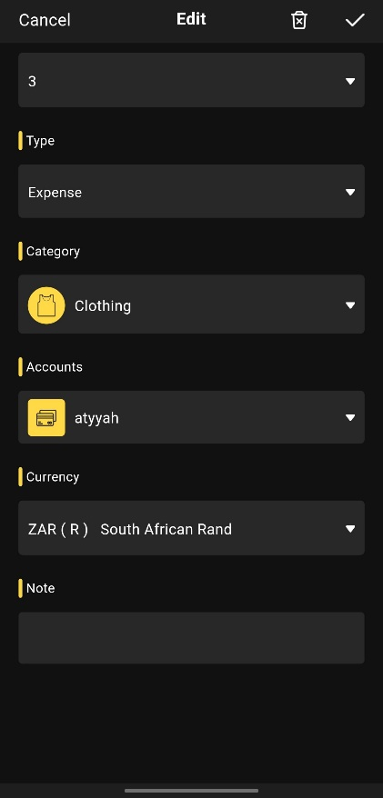

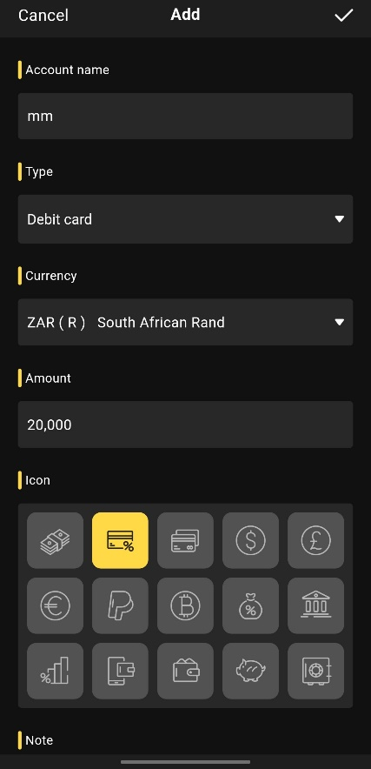Accounts page: This allows users to manage multiple accounts in one place. When a user adds a new account they have to input the account name, type, currency and amount. For the amount type users can choose if they are using a physical or a virtual card and what type of account it will be such as a credit or debit account. If you select a credit account the app will allow the user to input the amount that they will owe on the card and it is added to liability amount. This page displays your total net worth, assets, and liabilities across all your accounts. Through these pages, users can add information to the records page from the specific account, this data will appear on the main page (Money Tracker, 2022).

1. **Strengths and Weaknesses**

**Strengths:**

* Allows users to manage multiple accounts in one place, this includes online banking, E-Wallet, and crypto-wallet (Money Tracker, 2022).
* Once the users add in a financial activity the app automatically updates each display (Money Tracker, 2022).
* Allows users to schedule payments and add start dates and installments, making tracking easier (Money Tracker, 2022).
* Built-in calculator: The app allows users to add or subtract amounts before inputting them on the records page (Money Tracker, 2022).

**Weaknesses:**

* As a first-time user the app can be a bit difficult to navigate and it takes time to understand the features.
* In order to use certain features such as adding a team or business account, users have to pay R149,00.
* Although the UI is simple and uninteresting, it is not very aesthetic and to unlock the customizable features users will have to pay.

**C. Innovative Features:**

* Supports various currencies, aiding travellers and businesses by simplifying expense management and conversions.
* Enhances record-keeping by storing digital receipts, reducing errors, and ensuring proof of transactions.
* Combines multiple accounts for a real-time view of assets and liabilities, simplifying financial management.

**App 2: YNAB (You Need A Budget)**

1. **Overview including screenshots with descriptions**

YNAB is a powerful budgeting app designed to give users complete control over their finances by encouraging proactive financial planning. It follows a zero-based budgeting approach, where every dollar (or rand) is assigned a purpose (YNAB, 2025).

Users can securely link their bank accounts to YNAB, allowing for automatic transaction imports, ensuring real-time updates on spending and income (YNAB, 2025).

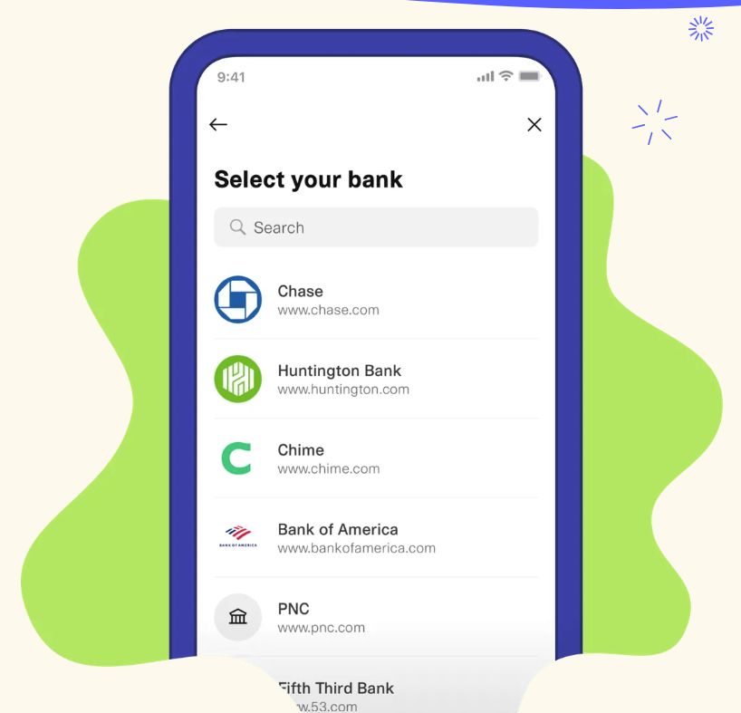

Figure 1: YNAB (2025). *Select your bank*. (YNAB, 2025)

The main interface consists of several key tabs:

* **Budget Tab:** This is the central hub where all expense categories are displayed, organized into three sections: Bills, Needs, and Wants. Below these sections, there is a Savings section showing the available funds. Users can allocate money to different categories, ensuring each financial goal is accounted for. For example, in the screenshot below we assigned R5000 from savings to New Car. accounted for. For example, in the screenshot below we assigned R5000 from savings to New Car.

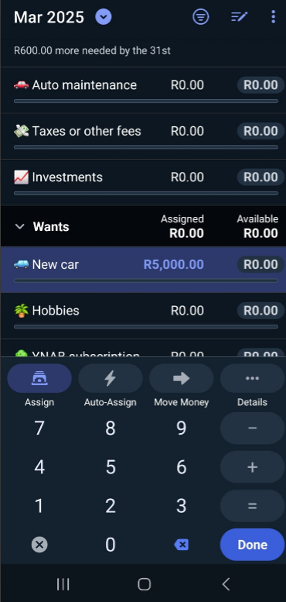

If a category has a savings goal, YNAB provides guidance on how much more needs to be allocated.

A three-month budgeting view allows users to toggle between past, present, and upcoming months, ensuring a long-term perspective on financial planning.



* **Accounts Tab:** Displays all connected financial accounts along with their balances, allowing users to track multiple accounts in one place.

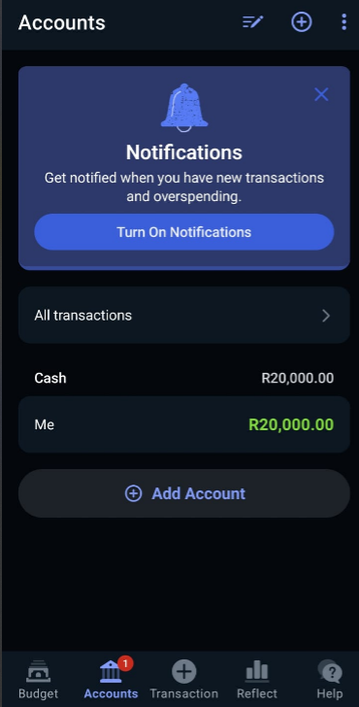

* **Add Transaction Tab:** Enables users to manually record income and expenses, specifying details such as category, date, and amount.

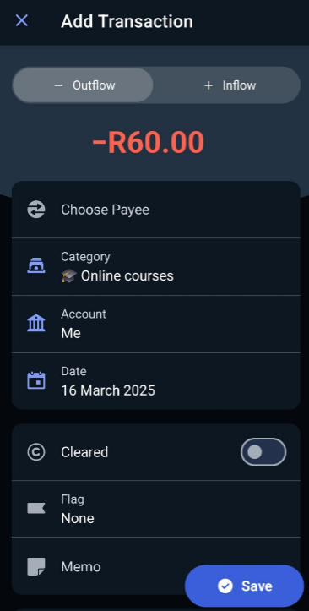

* **Reflect Tab:** Provides insightful spending breakdowns and net worth tracking through bar graphs, helping users analyze their financial trends over time.

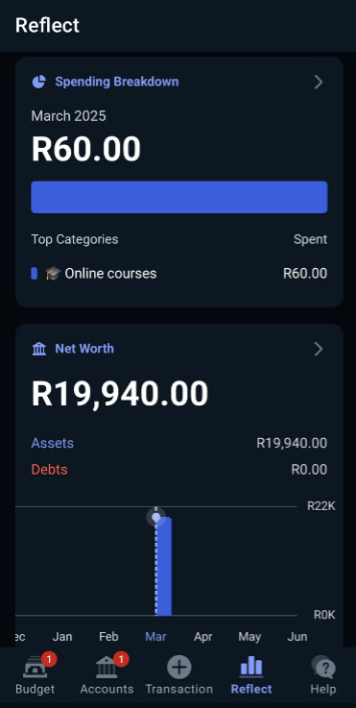

Overspending Alerts: If a user exceeds their budget in a particular category, the overspent amount is displayed in red, making it easy to spot and address financial shortfalls.

1. **Strengths and Weaknesses**

**Strengths:**

* Upon first use, YNAB asks questions about spending habits, financial goals, and unexpected expenses, ensuring a customized experience tailored to the user's needs.
* Users can add various bank accounts, name them, and categorize them as checking, savings, or credit accounts.
* Implements data encryption, two-factor authentication (2FA), and highly accredited data centres to protect sensitive financial data (YNAB, 2025).
* Accessible via computer, phone, or tablet, with real-time updates even when offline (YNAB, 2025).

**Weaknesses:**

* YNAB operates on a monthly subscription of R259.99 or an annual plan of R1699.99, which might be costly for users who are already on a tight budget.
* Unlike simpler budgeting apps, YNAB’s zero-based budgeting method requires users to actively engage in planning, which may take time to adapt to.

1. **Innovative Features**

* Unlike many budgeting apps, YNAB introduces a Templates Gallery, allowing users to quickly set up financial plans for major life events. This feature makes budgeting more accessible and helps users prepare for financial milestones with structured plans (YNAB, 2025).
* YNAB actively guides users toward their savings goals by displaying how much more needs to be allocated to a category in order to reach their financial targets. This motivates users to stay on track with their budgeting plans.
* Family and Partner Budgeting in One Subscription: YNAB allows up to six people to share a single subscription, making it ideal for families managing joint finances.

**App 3: Timely Bills**

* 1. **Overview including screenshots with descriptions**

TimelyBills is a personal finance app designed to help users manage their money effectively by tracking expenses, monitoring income, and achieving financial goals. The app offers features such as expense categorization, bill reminders, savings goal tracking, and detailed financial reports. With its intuitive interface and robust analytics, TimelyBills simplifies budgeting and empowers users to take control of their finances.

* Home Dashboard

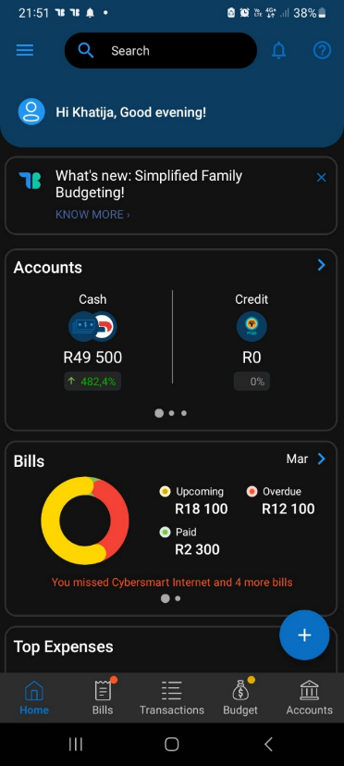

The home screen provides a comprehensive overview of the user’s financial status, including total income, expenses, and progress toward savings goals. It also highlights spending trends and account balances for quick reference.

* Expense Tracking Page

On this page users can view upcoming, overdue, recurring, and paid bills, allowing users to track their financial commitments efficiently. It categorizes payments, highlighting missed payments in red for better visibility and reminding users of upcoming expenses for the week. Each listed bill includes the payment name, amount, and due date. Users can also log daily expenses and assign them to custom categories like food, transportation, or entertainment, helping them monitor spending habits.

* Bill Reminders and recurring payments

TimelyBills ensures users never miss a payment by sending automated reminders for upcoming bills. It also tracks recurring transactions, making it easier to manage monthly expenses.

* A screenshot of a phone

  AI-generated content may be incorrect.Reports and analytics

The app generates visual reports to help users analyze their spending patterns and make informed budgeting decisions.

* Savings goal tracker

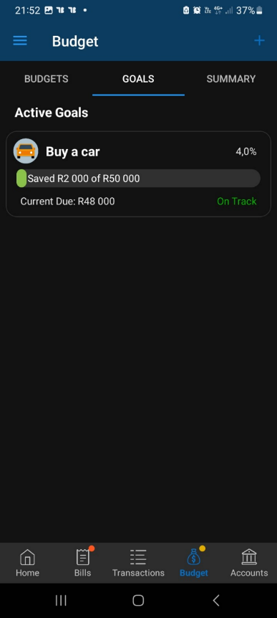

Users can set specific financial goals, such as saving for a car, and track their progress over time.

* 1. **Strengths and weaknesses**

**Strengths:**

* The app’s clean and user-friendly design makes it easy for anyone to navigate and use (TimelyBills, 2024).
* Detailed reports and visualizations help users understand their financial habits and make better decisions (TimelyBills, 2024).
* Automated reminders prevent late payments and help users stay organized (TimelyBills, 2024).
* Users can personalize categories and budgeting plans to suit their unique financial needs (TimelyBills, 2024).
* The TimelyBills website has detailed explanations on the features of the app and how to use it, making it easy for new users.

**Weaknesses:**

* Some advanced functionalities, such as bank synchronization require a premium subscription.
* New users might find the app overwhelming without proper guidance or tutorials.
* Advertisements in the free version can disrupt the user experience.
  1. **Innovative features**
* TimelyBills allows users to track expenses in different currencies, making it ideal for travellers or those managing international finances.
* The app enables multiple users, such as families, to collaborate on budgeting and expense tracking which is ideal for managing joint finances (TimelyBills, 2024).
* TimelyBills enhances financial literacy by providing users with data-driven insights and practical money management tips directly within the app. Users can access valuable articles helping them make informed financial decisions and optimize their budgeting strategies (TimelyBills, 2024).

Figure 2: TimelyBills (2024). *Daily Money Tips*. (TimelyBills, 2024)

**3. Infographic comparing all three apps**

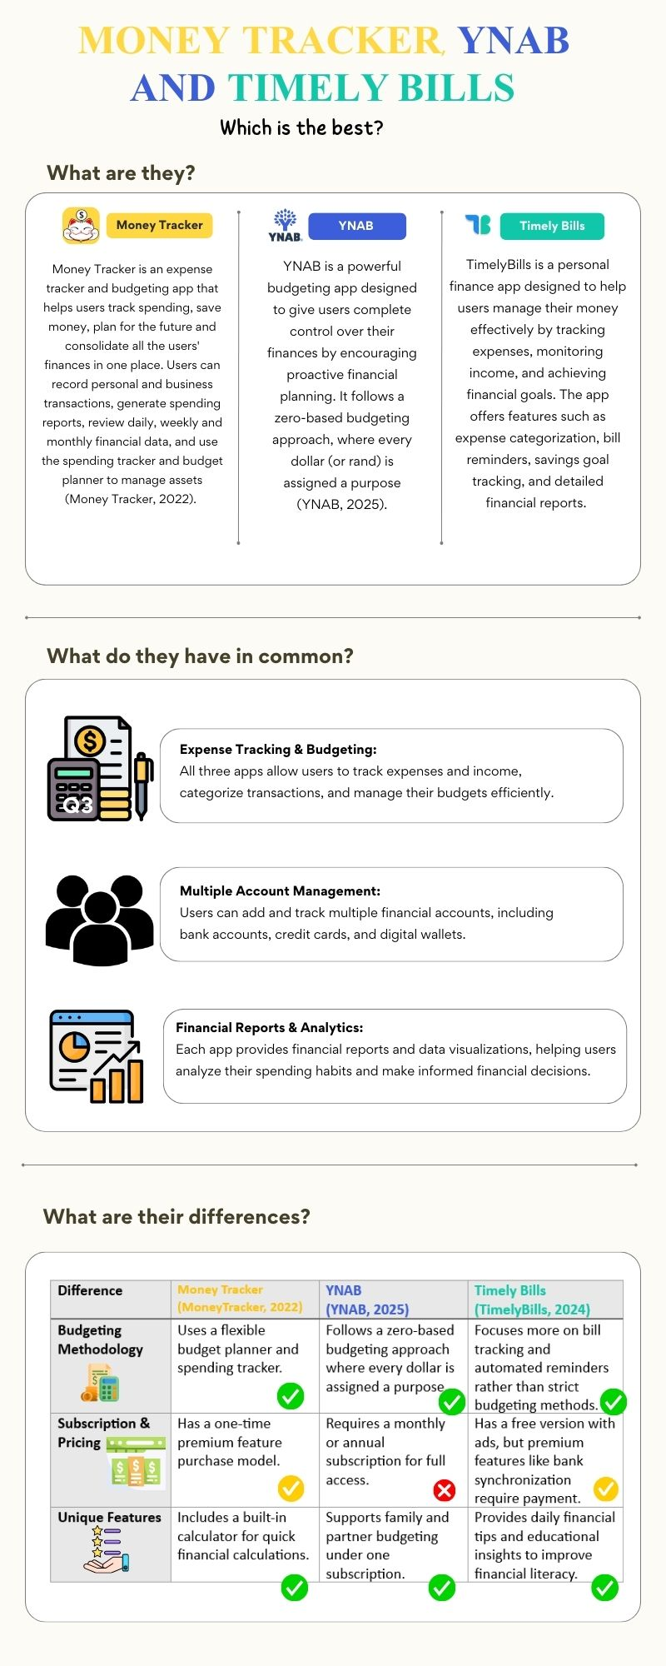

**4. A list of the best features from all the apps that we want to include in our app**

* Notifications: Timely bills make use of a notification feature which we will implement in our app. This feature sends users automated reminders to prevent late payments, updates them when a transaction occurs and informs them when new features are added to the app. Notifications are essential because they can help users in real-time rather than getting a statement at the end of the month (Baus, 2022).
* Multiple Currency: In all three apps there was the option of having different currencies Our app will implement this feature by allowing users to select a default currency and allow them to select from multiple different currencies when dealing with other accounts or inputting finances. This is a key feature as users might be frequent travellers and want to see how much they can spend in that specific country or users might deal with some of their finances internationally (Apocha, 2024).
* Financial literacy: Timely Bills provides users with data-driven insights and money management tips within the application (TimelyBills, 2024). Our app intends to enhance this feature by giving users access to relevant articles, videos and podcasts. By including multimedia we can ensure that the app is accessible to users with disabilities and different learning styles, therefore all users will have equal access to important information that will help them make well – informed financial decisions.
* Built-in calculator: Money tracker allows users to calculate their finances before adding the data to their records, but it only allows users to add and subtract. With our app we intend to take this feature and enhance it by allowing users to perform multiple functions on the calculator before inputting data. This feature will allow users to calculate exactly how much money they are earning or spending. It will also be easier when inputting multiple transactions under a singular category (Georgiou, 2024).
* Downloading Statements: YNAB allows users to download detailed statements regarding their transactions and budget for a specific month (YNAB, 2025). This feature gives users a detailed explanation of every transaction that occurred during that specific time without having to go back and search for therefore making the app more user-friendly and increasing user experience.
* Multiple accounts: In all three apps that were researched each app had a feature or similar feature regarding the use of multiple accounts which we would like to implement as well. By doing this, users can easily manage their loans and investments across multiple accounts through one app making it easier for them as all the important information is in one place (Petruk, 2023).
* Currency Exchange: All three of the apps we researched made use of multiple currencies. We want to improve on this feature by providing users with a designated currency exchange page, which will give users the live currency exchange rate. This makes it easier for users who work with different currencies because the exchange rates will be built into the app, and they won't have to go elsewhere to find it (Kasatikova, n.d.).

**5. Conclusion**

The development of our budgeting app is grounded in thorough research and a well-structured design. The research document provided key insights into effective financial management tools, user behavior regarding budgeting, and best practices for intuitive financial tracking. These insights shaped our app’s core features, ensuring that users can efficiently manage their expenses, track income, and gain financial awareness.

Our design document, which includes mock-up screens, user flow, and the overall project plan, translates these research findings into a practical and user-friendly solution. The structured layout, categorized expenses, and real-time budget tracking ensure that users have a seamless experience while maintaining financial control. The app's design prioritizes clarity and ease of use, making budgeting accessible for all users.

By aligning research with practical design, our approach ensures that the final product is both functional and user-centric, empowering users to take charge of their financial well-being effectively (OpenAI, 2024).

**6. Referencing**

Ante Baus, 2022. *Key features to consider when developing a personal finance app*.[online] Available at: <https://decode.agency/article/personal-finance-app-features/> [Accessed 18 March 2025]

Apocha, 2024*. 15 features the best expense tracker and budgeting app should have.*[online] Available at: <https://apocha.info/blog/the-best-expense-tracker-and-budgeting-app/> [Accessed 19 March 2025]

Elena Kasatikova, n.d. *How can you find budgeting apps that allow you to track expenses in multiple currencies.*[online] Available at : [https://www.linkedin.com/advice/0/how-can-you find-budgeting-apps-allow-track vgeif#:~:text=According%20to%20me%20to%20find,confirm%20multi%2Dcurrency%20tracking%20capabilities](https://www.linkedin.com/advice/0/how-can-you%20find-budgeting-apps-allow-track%20vgeif#:~:text=According%20to%20me%20to%20find,confirm%20multi%2Dcurrency%20tracking%20capabilities). [Accessed 19 March 2025]

Maksym Petruk, 2023*. How to make a budget app: From features to design considerations.*[online] Available at: <https://wesoftyou.com/fintech/budget-app-development-essential-features-and-monetization-strategies/> [Accessed 18 March 2025]

Michael Georgiou, 2024.*A complete guide to building a personal finance app in 2025.* [online] Available at : <https://imaginovation.net/blog/building-personal-finance-app/#key-features-to-include-in-your-personal-finance-app> [Accessed 18 March 2025]

Money Tracker, 2022. *Expense & Budget.* [online] Available at: <https://play.google.com/store/apps/details?id=com.freeman.moneymanager&hl=en_ZA&pli=1> [Accessed 17 March 2025].

OpenAI. 2024. Chat-GPT (Version 4). [Large language model]. Available at: <https://chat.openai.com> [Accessed: 19 March 2025].

TimelyBills, 2024. *Managing money is easy with TimelyBills*. [online] Available at: <https://www.timelybills.app/> [Accessed 17 March 2025].

YNAB, 2025. *A better outcome for your income*. [online] Available at: <https://www.ynab.com/features> [Accessed 16 March 2025].

**Annexure**

**Disclosure of AI Usage in my assessment**

**Section(s) within the assessment in which generative AI was used**

Conclusion

**Name of AI tool(s) used**

OpenAI, ChatGPT

**Purpose/intention behind use**

Writing a well phrased conclusion that ties up our entire research

**Date(s) in which generative AI was used**

19 March 2025

**Screenshot**

